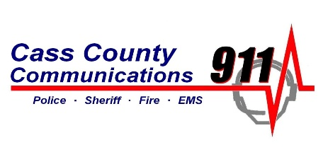Cass County Public Safety Communications is accepting applications for the position of Dispatcher. This position requires a high school diploma or GED. Previous dispatch experience is preferred, but not required. Applicants must be willing to work all shifts, including weekends and holidays. Successful candidates must show the ability to work and multi-task in the high paced environment of a 911 communications center. Excellent written and verbal communications are required and candidates must show a typing proficiency of 30wpm or greater. Applications may be picked up at the Cass County Auditor’s Office, Cass County Sheriff’s Office or [www.casscountyiowa.us](http://www.casscountyiowa.us) and will be accepted until job is filled at the same offices at 5 W 7th Street, Atlantic, Iowa, or by email at [mkennon@casscoia.us](mailto:mkennon@casscoia.us), E.O.E.